SCHOOL COMMUNITY COUNCIL
ELECTIONS

School Community Councils are elected parent/guardian and employee representatives who work together with the principal to increase student achievement. By law the Council is responsible to review school data and develop plans for school improvement. Councils also allocate the Land Trust funds to assist the school in reaching achievement goals. Please see the School Land Trust web page for more information regarding the roles and responsibilities of Community Councils (www.schoollandtrust.org).

Parents elect parent representatives and employees elect employee representatives for a two-year term. To be eligible, a parent must have a student enrolled in the school for at least one of the years. A parent representative may work for the district, but not this school. However, the SCC must have more non-working representatives than those employed by the district. Elections are held in the fall. We currently have five parent openings. Nominations will be open until September 4th. The Election will take place the week of September 9th through the 15th.

The District holds training to help you understand your responsibilities. Those trainings occur in October See the schedule on page 2 for more details.

We invite you to become involved in your school’s Community Council by declaring your candidacy. Please return this form by September 4th to Principal Scott Jameson scott.jameson@canyonsdistrict.org
______________________________________________________________________________________________________________DECLARATION OF CANDIDACY: I want to be a candidate for the School Community Council
Parent/Guardian Printed Name: ___________________________________________ Phone: ____________________

I am the parent/guardian of student(s): □ Check if you are also an employee of the district
______________________________________________________ ____________________________________________________
First/Last Name Grade First/Last Name Grade

Email Address: _____________________________________________________________________________________
Most communication will be done through email, so make sure you give us an email address you check regularly.

The Canyons Board of Education encourages schools to share information with their patrons about each candidate. Please write a couple of sentences about your reasons for running for the Community Council:
_______________________________________________________________________________________________________________
_______________________________________________________________________________________________________________
_______________________________________________________________________________________________________________
_______________________________________________________
Signature Date

School Community Council Training Dates
for 2020-21

In order for the SCC to functional well, training is vital. First time SCC representatives will need to attend both the SCC 101 and the SCC Training classes. Continuing members only need to attend the SCC Training class.

The SCC 101 will be completely online this year. More details to come.

The SCC Training will be both online and in-person at on the following dates:

- September 16, 2020 10:00 AM -or- 6:30 PM
- October 1, 2020 1:00 AM -or- 6:30 PM

In person sessions will be limited to 25 people/session. You will need to sign in advance via sign-up genius. More details will be emailed to new members.

Location: All events are in PDC (Canyons Center) at the Canyons Administration Building 9361 South 300 East. Each in-person training will last approximately 1 hour.

Tentative Alta View Elementary SCC Meeting Schedule
for 2020-21
Meetings are typically held the 3rd Tuesday of the month from 3:15 to 4:15 PM in the Faculty Room.
- September 29, 2020
- October 20, 2020
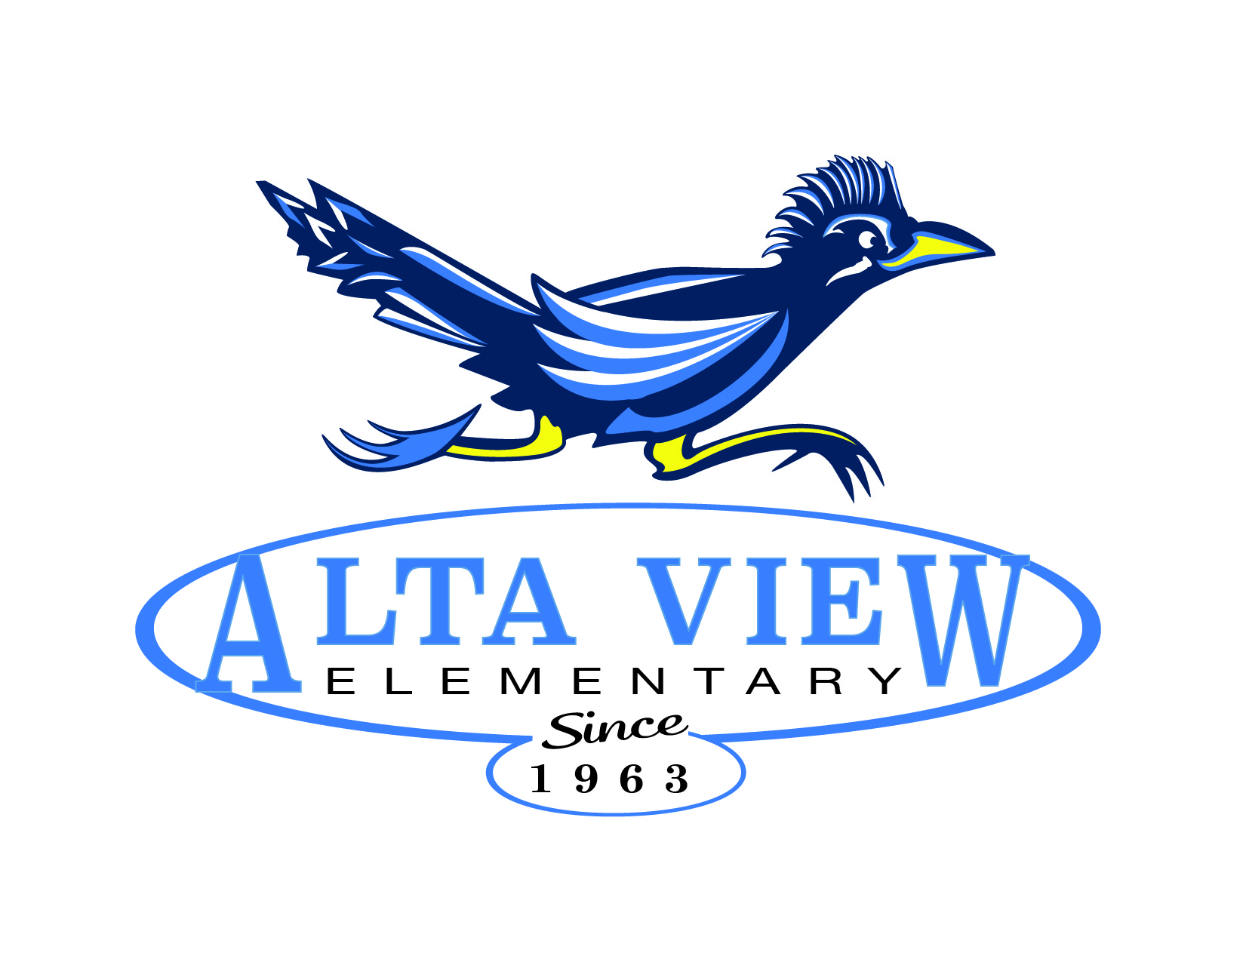
- November 17, 2020
- December - No Meeting
- January 19, 2021
- February 16, 2021
- March 16, 2021
- April 20, 2021
- May 18, 2021

